**UNITS OF MEASURE**

**TO START   
1.) Menu  
2.) Maintenance  
3.) Unit of measure**

Unit of Measure

Maintenance

Menu

3 1*1*

2 1*1*

1 1*1*

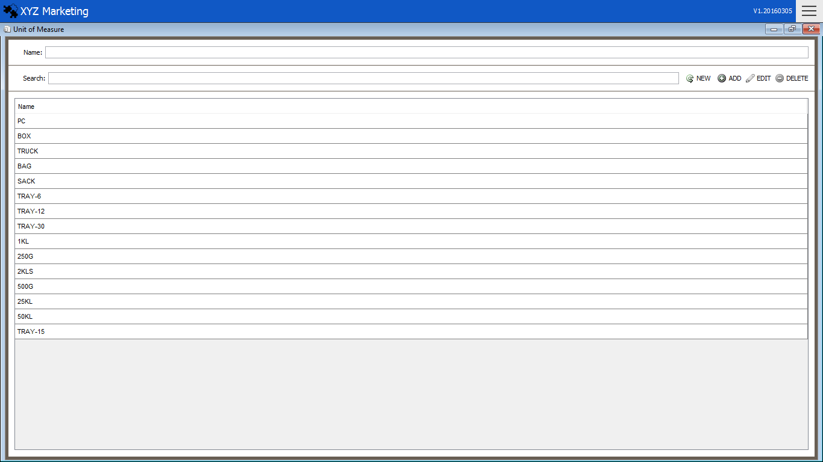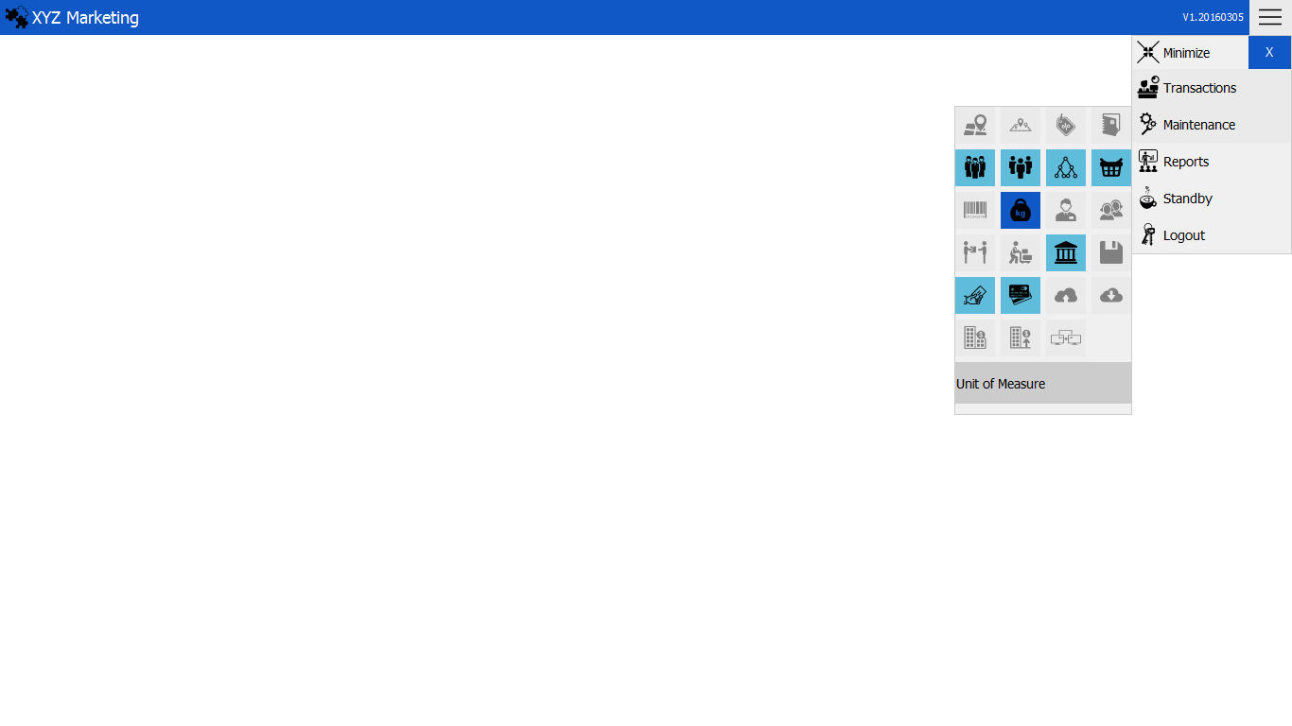

Search box

2 1*1*

Unit of Measures

**NEW Unit  
 1. ) Input name of the unit  
 2. ) Add**

Add

Name

1 1*1*

** 1. ) Input name of the unit of measurement**

Input the name of the unit of measurement you want to add.

**2. ) Add, edit & delete**

** 2.1) Add**

Click the add button to add unit measure.

**2.2) edit**

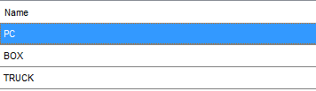



Click a unit of measure in the table

Click the edit button to edit unit measure.

**2.3) delete**

Click a unit of measure then click the delete button to delete.